

**American International University-Bangladesh (AIUB) Department of Computer Science**

**Software Quality and Testing**

**Spring 2020-2021**

**Project on** Developing a Test Plan for a AIUB Bank ATM Systems

**Section: D**

**Submitted By**

|  |  |
| --- | --- |
| **Name** | **Id** |
| Hoque, Fahmeda | 18-36767-1 |
| Rabib, Shahnure | 17-35298-2 |
| Mim, Ommay Salma RAHMAN | 18-36021-1 |
| Roy, Sumon | 17-33627-1 |

**Submitted to**

**S.M. Abdur Rouf Bhuiyan**

**Department of Computer Science**

**Faculty of Science & Technology**

**American International University-Bangladesh**

|  |  |  |
| --- | --- | --- |
| **SL** | **Content** | **Page** |
| **1** | **TEST CASE IDENTIFIER** | 3 |
| **2** | **REFERENCES** | 3 |
| **3** | **INTRODUCTION** | 3 |
| **4** | **TEST ITEMS** | 4 |
| **5** | **FEATURES TO BE TESTED** | 4-8 |
| **6** | **SOFTWARER RISK ISSUES** | 8 |
| **7** | **FEATURES NOT TO BE TESTED** | 9 |
| **8** | **APPROACH** | 9 |
| **9** | **ITEM PASS/FAIL CRITERIA** | 9 |
| **10** | **SUSPENSION CRITERIA AND RESUMPTION REQUIREMENT** | 11 |
| **11** | **TEST DELIVERABLES** | 12 |
| **12** | **REMAINING TEST TASKS** | 12 |
| **13** | **ENVIRONMENTAL NEEDS** | 13 |
| **14** | **STAFFING AND TRAINING** | 13 |
| **15** | **RESPONSIBILITIES** | 14-15 |
| **16** | **SCHEDULE** | 16 |
| **17** | **PLANNING RISKS AND CONTINGENCY** | 16 |
| **18** | **APPROVALS** | 16 |
| **19** | **GLOSSARY** | 16 |

**1. Test Plan Identifier**

Developing a Test Plan for AIUB Bank ATM Systems 1.2

**2. References**

* + - Kelly, J. C., Sheriff, J. S., & Hops, J. (1992). An analysis of defect densities found during software inspections. Journal of Systems and Software, 17(2), 111-117.​
    - R.S. Pressman & Associates, Inc. (2010). Software Engineering: A Practitioner’s Approach.​
    - http://www.cs.umd.edu/projects/SoftEng/ESEG/papers/Reading_Lists/Jeff_Carver.pdf
    - Software Quality Engineering - Testing, Quality Assurance and Quantifiable Improvement -Jeff Tian.pdf

**3. Introduction**

This test plan is about the testing approach and overall framework of the AIUB Bank ATM Systems. Unit testing will be done at the beginning. Integration testing will be next. After that, the System Testing will be done. Finally, acceptance testing will finish the job. AIUB Bank Limited has automated teller machines (ATMs) which are geographically distributed and connected via a wide area network to a central server. Each ATM machine has a card reader, a cash dispenser, a touchscreen display, and a receipt printer. By using the ATM machine, a customer can withdraw cash from either checking or savings account, query the balance of an account, or transfer funds from one account to another.

**4. Test Items**

|  |  |
| --- | --- |
| **Item** | **Version** |
| 24/7 service | **1.2** |
| Balance availability information display | **1.2** |
| Money Withdrawal time display | **1.2** |
| Touch screen menu selection | **1.2** |
| One bank to another bank money transactions | **1.2** |
| Multiple time Money Withdrawal in one transaction | **1.2** |
| Cancellation of transactions any time during transaction | **1.2** |
| Credit/Debit card transaction | **1.2** |
| Card Information | **1.2** |
| Check the Pin Number | **1.2** |
| Check Customer records, account records, and debit card records | **1.2** |

**5. Features to be tested**

* + Business level requirements:
* The software fulfills the requirement for which it is being made, that is it provides a platform for successful.
* The software solves the problem user mentions.
* Project feasibility is examined.
* Project objectives align with problem statement and project vision.

User level requirement:

|  |  |
| --- | --- |
| Requirement # | Description |
| R_C_01 | The software will support interface to touch screen monitors as well as keyboard interface. |
| R_C_02 | The software will support display of the list of Balance, their information and Money Withdrawal time display. |
| R_C_03 | The software will support multiple card punch simultaneously. |
| R_C_04 | The software will support limiting the money Withdrawal at the same time. This privilege control will be done by the administrator access only. |
| R_C_05 | The software will support money Withdrawal cancellation before final confirmation of the Withdrawal. |
| R_C_06 | The software will support Money Withdrawal cancellation support by the administrator. |
| R_C_07 | The software will support credit/Debit transaction and validation. |
| R_C_08 | The software will support next and previous Money Withdrawal information during money Withdrawal process. |
| R_C_09 | The software will support Money Limit availability information. |
| R_C_10 | The software will support information display via web. |
| R_C_11 | The software will Use to Check the Pin Number more than three times. |

Product level requirement:

* The back end of the software shall be written in an object-oriented programming language.
* The software design shall implement object-oriented concepts.

|  |  |  |  |  |  |  |
| --- | --- | --- | --- | --- | --- | --- |
| Test case no# | Action/ description | Requirement # | Expected result | Actual result | Pass/ fail | Comment |
| T_C_01 | support interface to touch screen monitors as well as keyboard interface | R_C_01 | Supports both the systems. (Touch screen as well as keyboard system) | Supports both the systems. (Touch screen as well as keyboard system) | Pass |  |
| T_C_02 | Display of the list of Balance, their information and Money Withdrawal time | R_C_02 | Successfully displayed all the information | Successfully displayed all the information | Pass |  |
| T_C_03 | Multiple card punch simultaneously | R_C_03 | Card Punch Successfully | Card Punch Successfully | Pass |  |
| T_C_04 | Support limiting the money Withdrawal at the same time. This privilege control will be done by the administrator access only | R_C_04 | Support limiting the money Withdrawal | Support limiting the money Withdraw Successfully  At the same time | Pass |  |
| T_C_05 | Money Withdrawal cancellation before final confirmation of the Withdrawal | R_C_05 | Showed the display Money Withdrawal cancellation before final confirmation of the Withdrawal | The display will show Money Withdrawal cancellation before final confirmation of the Withdrawal | Pass |  |
| T_C_06 | Money Withdrawal cancellation support by the administrator | R_C_06 | Successfully Withdrawal cancellation support by the administrator | Successfully Withdrawal cancellation support by the administrator | Pass |  |
| T_C_07 | support credit/Debit transaction and validation | R_C_07 | Successfully support credit/Debit transaction and validation | Successfully support credit/Debit transaction and validation | Pass |  |
| T_C_08 | support next and previous Money Withdrawal information during money Withdrawal process | R_C_08 | Successfully support next and previous Money Withdrawal information during money Withdrawal process | Successfully support next and previous Money Withdrawal information during money Withdrawal process | Pass |  |
| T_C_09 | support Money Limit availability information | R_C_09 | Successfully  Displayed Money Limit availability information | Successfully  Displayed Money Limit availability information | Pass |  |
| T_C_10 | support information display via web | R_C_010 | Successfully  support information display via web | Successfully  support information display via web | Pass |  |
| T_C_11 | Use to Check the Pin Number more than three times | R_C_11 | Successfully  allow the customer to enter the correct PIN in no more three attempts | Successfully  allow the customer to enter the correct PIN in no more three attempts | Pass |  |

**Bug report:**

Bugs in any portion of the testing phase are to be reported in Trello software. A board called bug tracking is set up and a Trello card is added for each bug. From time to time, this bug report is looked into by project members to locate and provide solutions for errors in current or future versions.

**6. Feature not to be tested**

* the software should not be tested with online e-commerce banking like (bkash, ucash, nogod etc).
* The usage of voice command should not be tested
* Cash exchange should not be tested

**7. Approach**

* The following project represents the all flow the testing approach:  
  ⮚ Identify the requirements to be tested. All test cases shall be derived using the current Program Specification.
* ⮚ Identify which particular test(s) will be used to test each module
* ⮚ Identify the expected results for each test
* ⮚ Perform the tests
* ⮚ Successful unit testing is required before the unit is eligible for component  
  integration/system testing.

**8. Item pass/fail criteria**

* The test process will be completed when the software is able to perform the tasks it is intended to do for 80% of the time without any major error and also portray successful functioning of other prioritized requirements mentioned.

**9. Item pass/Fail**

In this section of the test plan describes the pass/fail criteria for each of the items described in Test items. This is a critical aspect of the plan, as it provides the criteria that will indicate that testing of an item/feature will be completed.

Sample Pass/Fail criteria for system 90% of the test cases should pass.

All the cases dealing with critical functionality should pass. All medium and high severity defects should be fixed.

Test coverage should be at least 90%.

At the unit testing:

* If the source code of the small units gives expected result, then the item will be passed.
* The developer will fix the constraints and signatures of the design specification if the test case fails.

At the integration testing:

* If the outcomes of the merging units are accurate, then the test case will be passed.
* In case of failure, the developers will fix the problems.

At the system testing:

* If the entire set of test cases passes, then the system testing will pass.
* If system testing is fails, then the entire process will start from the beginning.

At the acceptance testing:

* If the client did not accept the software according to their requirements, then the test will be failed.
* In that circumstances the software will be rejected.

**10. Suspension Criteria and Resumption Requirementr**

Suspension criteria specify the criteria to be used to suspend all or a portion of the testing activities while resumption criteria specify when testing can resume after it has been suspended.

* Unavailability of external dependent systems during execution.
* When a defect is introduced that cannot allow any further testing.
* Critical path deadline is missed so that the client will not accept delivery even if all testing is completed.
* A specific holiday shuts down both development and testing.

System Integration Testing in the Integration environment may be resumed under the following circumstances:

* When the external dependent systems become available again.
* When a fix is successfully implemented and the Testing Team is notified to continue testing.
* The contract is renegotiated with the client to extend delivery.
* The holiday period ends. Holidays of the workers in both development and Testing department should maintained properly. Unnecessary extra holidays may Suspense project development.

Suspension criteria assumes that testing cannot go forward and that going backward is also not possible. A failed build would not suffice as you could generally continue to use the previous build. Most major or critical defects would also not constitute suspension criteria as other areas of the system could continue to be tested. Testing suspension is the step that from where going forward is impossible with the going backward.

**11. Test Deliverable**

Projects create deliverables, which are simply the results of the project or the processes in the project. That means a deliverable can be something as big as the objective of the project itself or the reporting that is part of the larger project. Test Deliverables are the artifacts which are given to the stakeholders of software project during the software development life cycle. There are different test deliverables at every phase of the software development life cycle. Some test deliverables are provided before testing phase, some are provided during the testing phase and some after testing cycles is over.

* Test Strategy
* Test Plan Document
* Test Cases
* Test Summary Report
* Test Evaluation Report

**12. Remaining Test Task**

* Create Acceptance testing plan
* Create System/Integration Test Plan
* Define Unit Test rules and Procedures
* Infrastructure components.
* Readily available components.
* GUI response and Relational Database testing
* Readily available components.
* Infrastructure components.
* Database connectivity testing
* Verify prototypes of screen
* Verify prototypes of Reports

**13. Environmental Needs**

* Require Database Server to execute the system.
* Hardware components and software are needed to execute the system.
* Network configuration and connectivity needs to run the system.

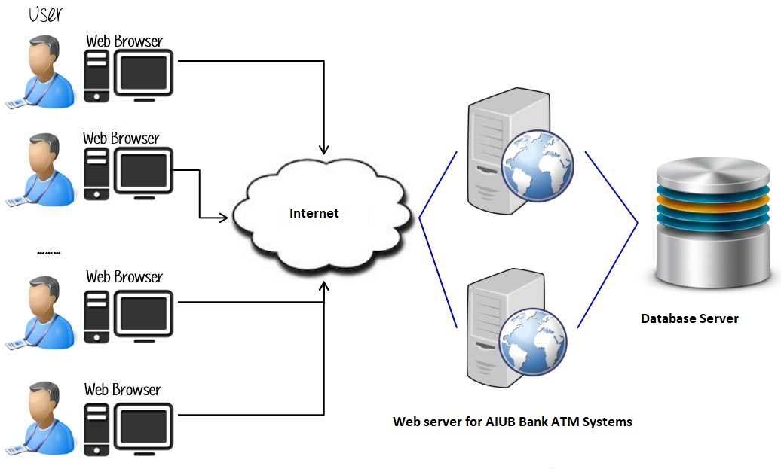

**14. Staffing And Training**

This section outlines approach staffing and training the test roles for the project. Staffing fixed for the duration of this project. It is likely most of the staff will assume some testing role.

**15. Responsibilities**

|  |  |  |
| --- | --- | --- |
| No | Member | Tasks |
| 1 | Test Manager | * Manage the whole project * Define project directions * Acquire appropriate resources |
| 2 | Tester | * Identifying and describing appropriate test techniques. * Verify and assess the test approach * Execute the test cases, Log results, Defect reports. * Submit, Reopen close issues in Bug Tracker (JIRA). |
| 3 | Test Administrator | * Builds up and ensures test environment and assets are managed and maintained * Support tester to use the test environment for test execution |

**16. Schedule And Estimation**

|  |  |  |
| --- | --- | --- |
| Task | Member | Estimate effort |
| 1. Create the test specification, plan and set up tester environment | Test Manager | 90 man-hour |
| 2. Perform Test Execution | Tester | 135 man-hour |
| 3. Test Report & Release note | Tester | 27 man-hour |
| 4. Test Delivery | Test Manager | 18 man-hour |
| Total: |  | 270 man-hour |

**17. Schedule**

|  |  |  |  |
| --- | --- | --- | --- |
| **Milestones** | **End Dates** | **Notes** | **QA Roles** |
| Planning Phase | 01/04/2021 | The high-level planning should be completed. Some of the deliverables are: Project Plan, Program function specifications | High-level test planning activities, which include preliminary development of Master QA Plan. |
| Code Complete - Infrastructure | 03/04/2021 | This milestone is when all infrastructure development and functions should be complete. | The Test Engineers should have completed or in the final stages of their preliminary Infrastructure Test Plan, test cases and other QA documents related to test execution for each feature or component such as test scenarios, expected results, datasets, test procedures, scripts and applicable testing tools |
| Code Complete-Functions | 06/04/2021 | This phase allows for feature clean up to verify remaining bug fixes and regression testing around the bug fixes. | The Test Engineers should have provided Code Complete Assessment Test to Development Engineer one week prior to Code Complete Review date. The Test Engineers should also have completed or in the final stages of their preliminary White Box Test Plan, test cases and other QA. |
| Feature Complete | 08/04/2021 | This phase allows for feature clean up to verify remaining bug fixes and regression testing around the bug fixes. | All bugs verified and QA documentation is finalized. |
| Regression Test | 12/04/2021 | This milestone represents that all automation AIUB atm bank system application code and GUI interface of the AIUB atm bank system | Complete regression test execution of complete system and update Test Summary Reports for regression. |
| Live | 20/04/2021 | Product is out | Any unfinished Testing documents should be complete by this period. |

**17. Planning Risk And Contingency**

**Risk during personal schedule:** Unable to acquire the necessary number of skilled personnel as the components become ready to test.

**Contingency:** Resources for components will be split between the existing resources. Schedule must be adjusted accordingly.

**Risk during equipment:** Unable to acquire some of the necessary hardware and software required for integration and system testing.

**Risk during schedule:** Components are not delivered on time.

**18. Approvals**

|  |  |  |  |
| --- | --- | --- | --- |
| **Name** | **Designation** | **Institute** | **Date** |
| S.M Abdur Rouf Bhuiyan | Project Sponsor | Datasoft, Inc | 1/03/2021 |
| Sumon Roy | Project Manager | Datasoft, Inc | 1/03/2021 |
| Shah Noor Rabib | Test Manager | Datasoft, Inc | 1/03/2021 |
| Fahmeda Afnan Ashfe | Development Manager | Datasoft, Inc | 1/03/2021 |
| Salma Rahman Mim | Quality Assurance | Datasoft, Inc | 1/03/2021 |

**19. Glossary**

|  |  |
| --- | --- |
| **PM** | Project Manager |
| **Test Case** | Test case has always four phases: preparation, execution, verification, andfinalization. Test execution differs from normal execution in that there is this verification part. |
| **Test Data** | The information that is given to the system and expected to get back from the system. Also real feedback received from the SUT can be considered as test data |
| **Test Suite** | A collection of test cases that have the same test objective. |
| **QA** | Quality Assurance |